


THE REAL SCHOOLS
LEARNER’S EMPOWERMENT ACTIVITY
P.4 SCIENCE TERM 1 2025
TOPIC GROWING CROPS.

Golden Junior
School

Makindye Junior School

Victoria P/S
An excellent first grade and excellent character for every pupil

NAME……………………………………………… ………………………CLASS: ………………………….
SCHOOL: ……………………………………………………………………………………………………………
THEME: World of living things.
TOPIC: Growing crops.
Learning out comes.
To enable the leaner to understand and describe crop growing practice
Back ground knowledge. Examples of plants.
Competences.
- Defines crops and example of crops.
- Gives types of crops and their examples
- Defines groups of crops and their examples
- States examples of garden tools
- Draws and labels different garden tools
- Gives the importance of each garden tools
- Gives ways of caring for garden tools
- Defines crop growing practices
- Gives examples of garden tools used.
CONTENT PHASE 1
Crops
Key Learning principles
Crops plants grown for a particular purpose.
Types of crops commonly grown
*Fruit crops
* Cereal/grain crops
* Vegetable crops.
_Legume crops
_ Roots crops
Cereals/ grain crops.
Cereals are plants that bear grains.
They are sometimes, called grains or monocots
Examples of cereals crops.
▪ Rice crops. ▪ Wheat crops ▪ maize crops ▪ Oat crops
▪ Sorghum crops Millet crops Barley crops

Leguminous crops legumes)
Legumes are plants with nodules on their roots.
They have seeds in pods.
Examples of legumes
♦Bean crops
♦ pea crops
♦Ground nuts crops
♦Soya bean crops
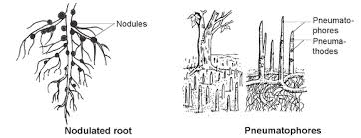
A diagram showing a root system of a legume

- Root nodules are swellings found on roots of leguminous plants.
- Root nodules keep nitrogen fixing bacteria (N F B)
- Nitrogen fixing bacteria fix nitrogen in the soil
- Nitrogen improves soil fertility.
- Nitrates help plants to grow well and make proteins.
MINI ACTIVITY.
1. What do you understand by the term a crop
_____________________________________________________________________________
2. Mention any three examples of crops grown in your community.
i) _______________________ii)_____________________iii)__________________________
3.How useful are legumes of cereal crops
______________________________________________________________________________
4. Write down any two examples of cereal crops.
i) _______________________________________ii)__________________________________
5. Mention any two examples of leguminous plants in our environment.
i) _________________________________ii________________________________________
FRUIT CROPS.
These are crops which provide fruits.
Examples of fruit crops.
- Apple crops. Orange crops
- mangoes. Pineapples crops
- pawpaw crops.
- Roots crops Root tubers)
These are crops which store their food in roots.
Examples of roots crops.
- Cassava crops sweet potato crops
- Carrot crops. Turnips
- Beet roots Beet roots
Types of vegetables eg cabbages, spinach.
- Root vegetables escargots and turnips
- Fruit vegables eg tomatoes, egg plants.
Groups of crops.
1. Annual crops.
2. Perennial crops.
Annual crops.
These are crops which take less than year to mature.
- They complete their life cycle with in one growing season and then die.
- They are also called seasonal crops.
- They are harvested once and die.
Examples of Annual crops.
_ peas , maize, Rice, beans, Sorghum, Cabbage, millet.
MINI ACTIVITY.
1. Name any one group of crops.
_____________________________________________________________________________
2. Give any two examples of fruits crops.
i) ____________________________________ ii) ____________________________________
3.Apart from perennial crops give any other group of crops.
___________________________________________________________________________
4. Why do crop farmers include legume when carrying out crop rotation?
____________________________________________________________________________
Perennial crops.
These are crops which takes more than a year to mature.
They live for many years and produce fruits and seeds many times in their lifetime.
They are harvested after every season.
Examples of perennial crops.
  - Tea Coffee
  - Cocoa. Bananas
- Oranges. Avocado
Garden tools
Are simple machines farmers use to carry out activities in the garden.
Activities that need garden tools.
- Land clearing. Collecting weeds and rubbish.
- Digging. Harvesting.
- Wedding. Transplanting.
- Planting Transplanting.
- Spraying. Transporting manure and crops
- Pruning
- Turning manure.
- watering
MINI ACTIVITY
1. Apart from perennial crops, give any other group of crops.
__________________________________________________________________________
2. Name any two example of root crops in the environment
__________________________________________________________________________
3. Why is tea and coffee ground under perennial crops?
__________________________________________________________________________
4. Mention any two examples of vegetable crops in our environment.
i) ________________________________ii)_______________________________________
MEGA ACTIVITY.
1. What do understand by the term a crop?
___________________________________________________________________________
2. Mention any two examples of crops grown in your community.
i) _____________________________ii)___________________________________________
2. Mention any two examples of crops grown in your community.
i) _________________________________ii)______________________________________
3. How useful are legumes to soil.
___________________________________________________________________________
4. Name any one group of crops.
___________________________________________________________________________
5. How important are nitrates found in the soil to plants.
__________________________________________________________________________

6. Which type of germination do leguminous plants undergo.
___________________________________________________________________________

7. Where do leguminous plants keep their seeds.
__________________________________________________________________________
8. Apart from cassava crops, give any two examples of root crops.
____________________________________ii)_____________________________________
9. Name the bacteria found in the root crops.
___________________________________________________________________________
10 Mention any two types of vegetables
i)___________________________________ii)_____________________________________
11.Adiagram showing root system of a legume use it to answer questions that follow

Y

11. Name part marked Y
_________________________________________________________________________
12. Give any two examples of legumes.
i) ________________________________ ii) ____________________________________

Garden Tool | Functions
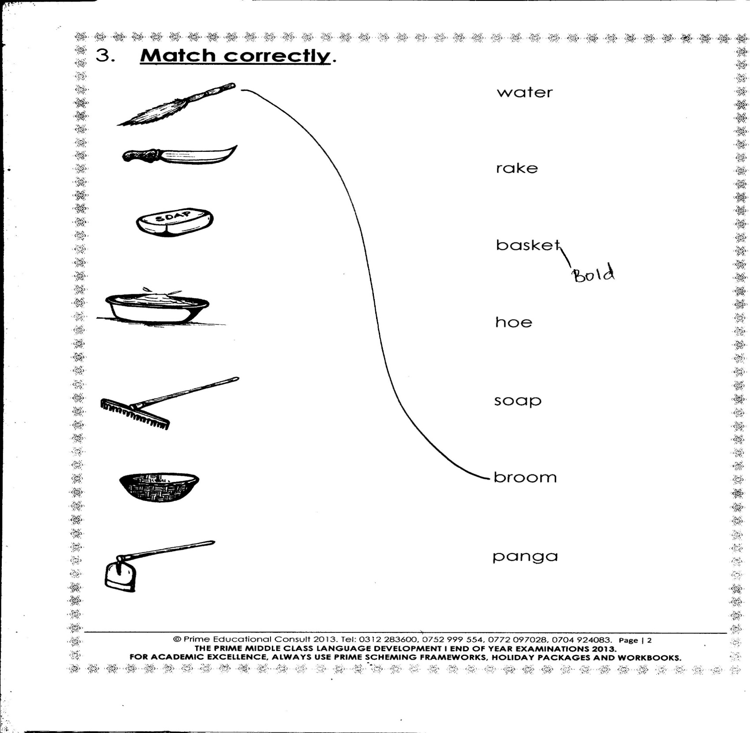  Hoe | Digging/planting/weeding/  Harvesting root crops  Ploughing the land.  Leveling soil
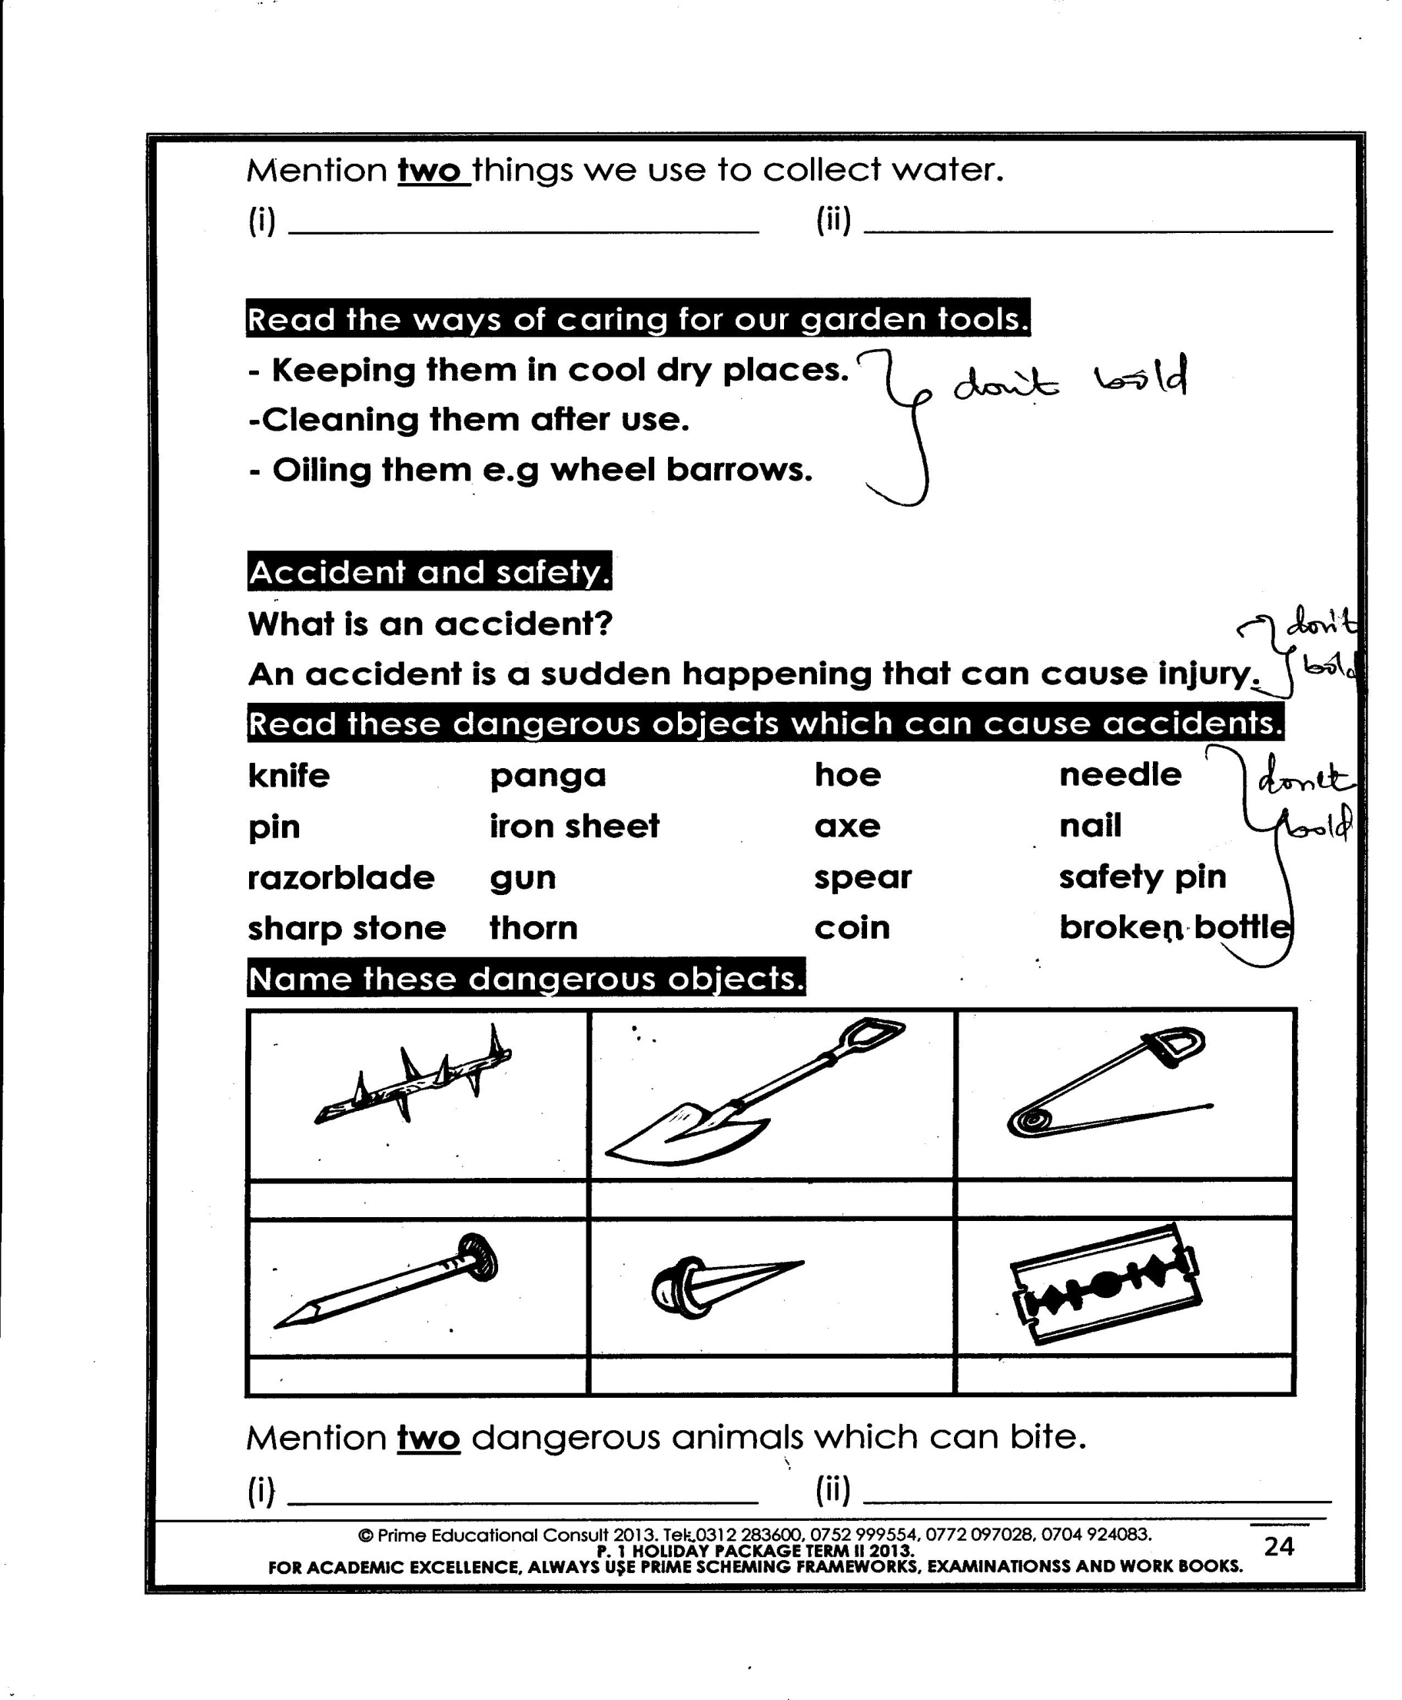  Spade | Mixing manure.  _Loading manure.  _Lifting soil  _Level the soil
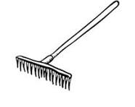  Rake | _ Leveling soil.  _Collecting water weeds and rubbish.  Spreading.
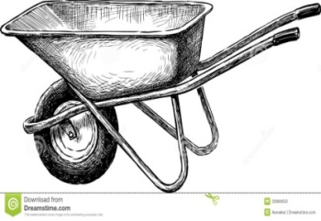  Wheel barrow | Transporting manures  _Carrying harvested crops  Transporting tools
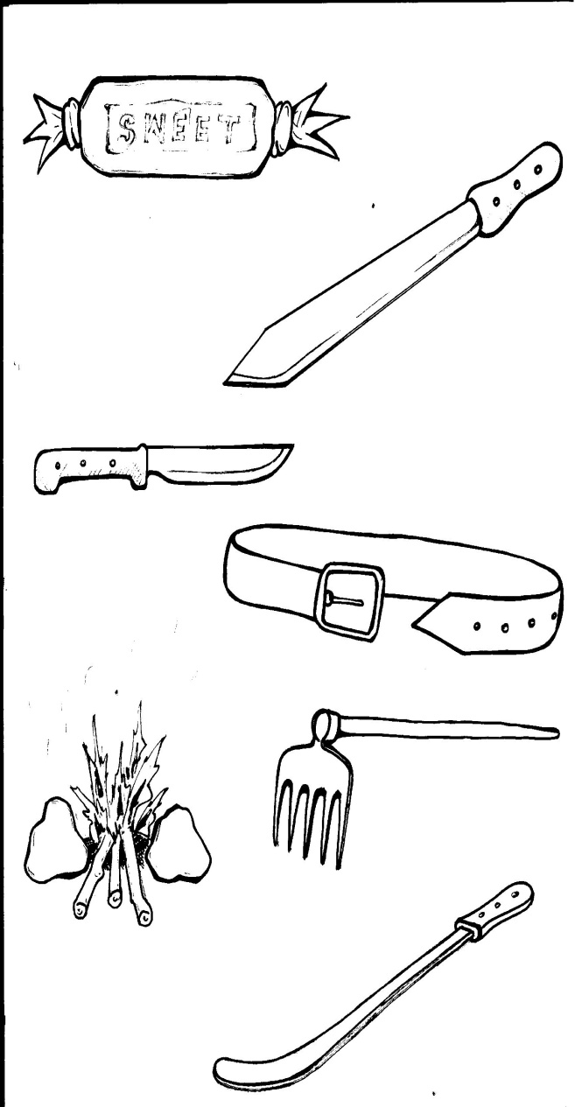  Slasher | _ Cutting grass.  _ slashing
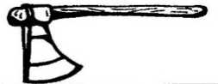  Axe | _ Cutting/felling big trees.  _chopping/splitting fire wood
panga | _ cutting small trees.  _ Harvesting some crops sugarcane  _Also pruning
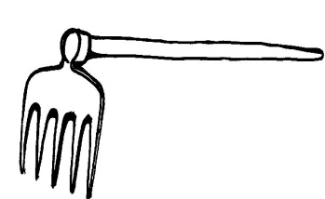  Forked hoe | _ digging hardground.  _ digging stony ground.
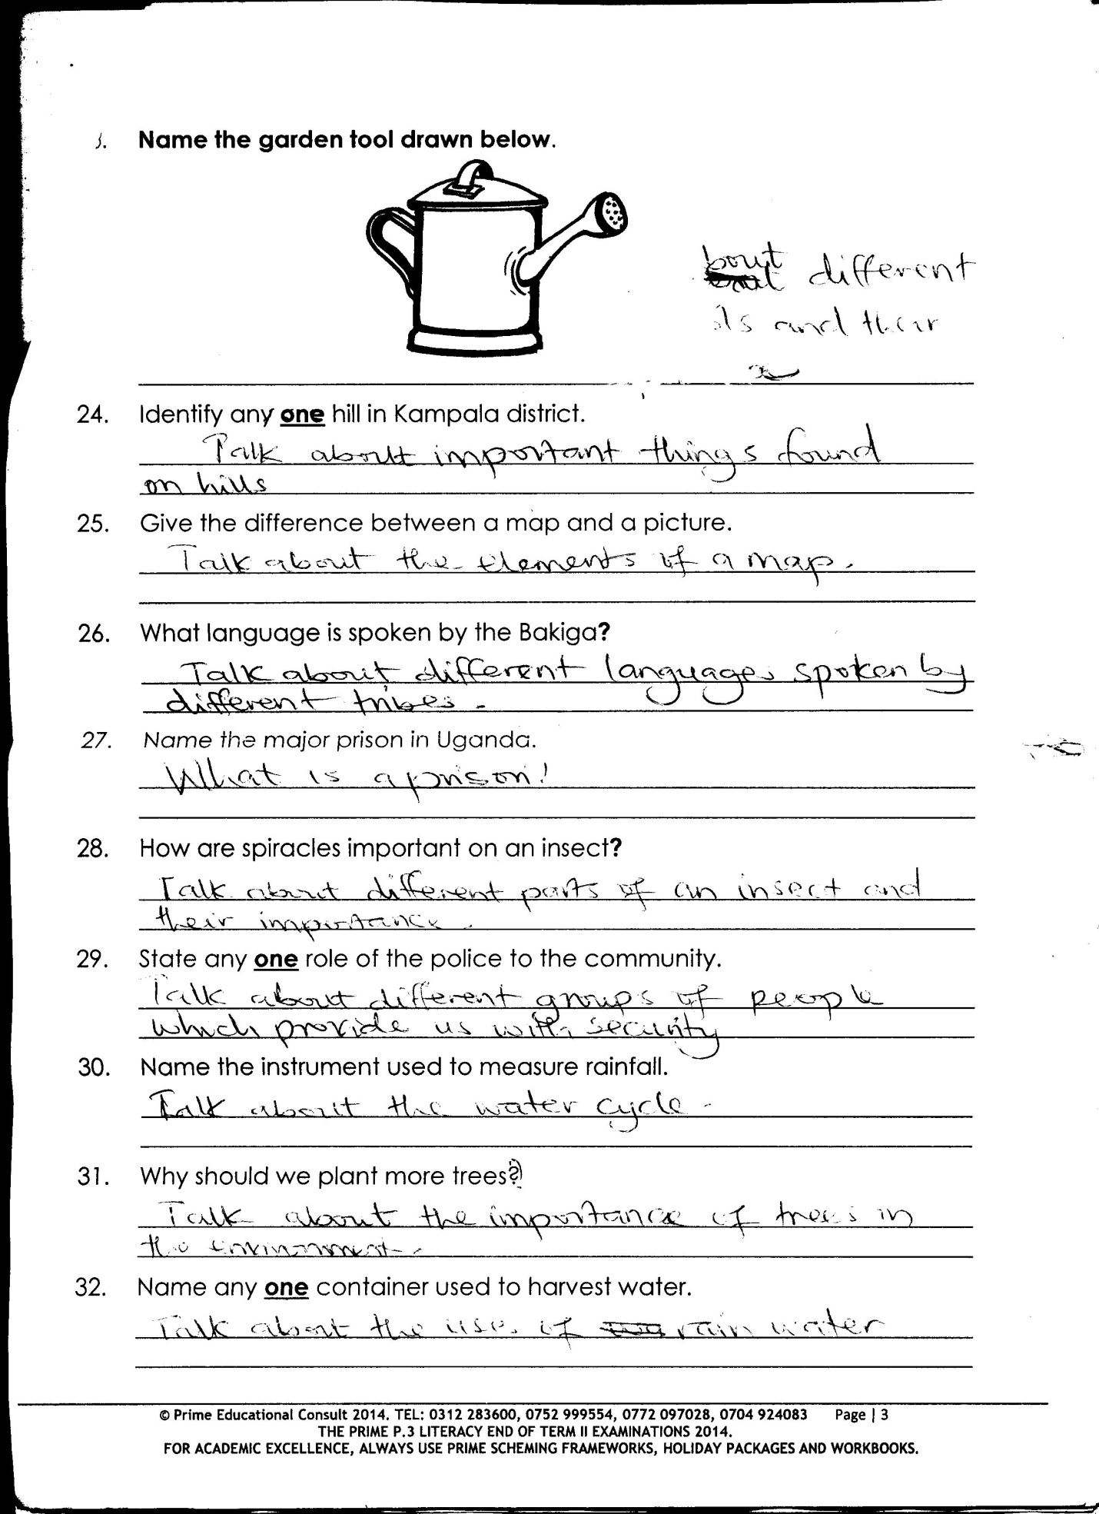  Watering can | _ watering crop.  _used for applying liquid fertilizers to the soil
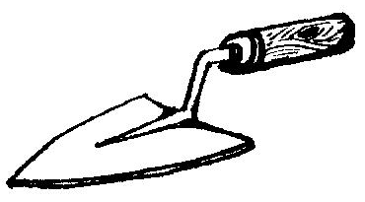  Trowel | _ Transplanting seedlings  _Also used for mixing and loosening the soil
_Mixing/ turning manure.
_ loading manure
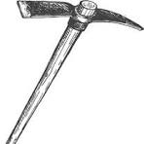  Pick axe | _Digging and breaking hard rocky ground  _ Digging in stony soils  _ uprooting trees stumps.
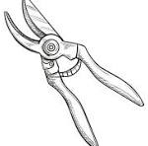  Secateurs and shears | _ pruning crops  _Trimming flowers and leaves
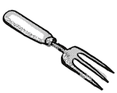  Hand fork | _Light weeding  _ Removing seedlings from soil  _Mixing soil with manure
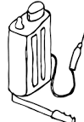  Knapsack sprayer | _ spraying pesticides to crops.  _ spraying liquid  _ fertilizers to crops
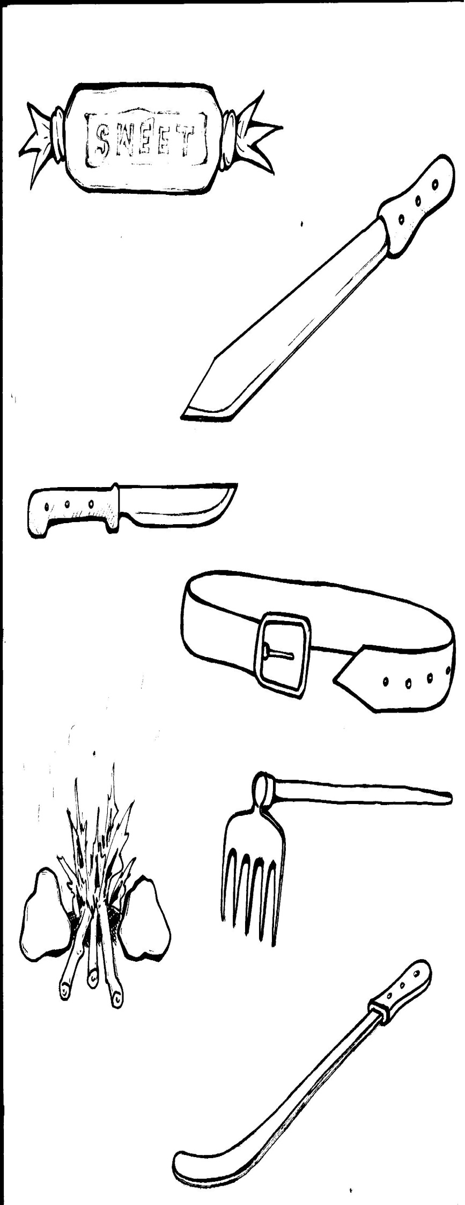  knife | _ Harvesting crops  _ panning bananas  _ peeling
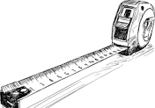  Tape measure | _ spacing crops in the garden
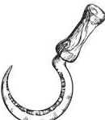  sickles | _ Harvesting cereals like millet and rice  _ cutting grass for animals  _ cleaning the bush
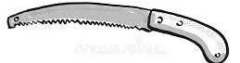  Pruning saw | _ used for pruning trees.
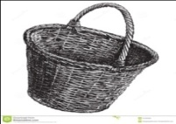  Basket | _ For carrying harvested crops and seeds

Caring for garden tools
Garden tools can be cared for through the following ways
- Washing and drying the tools after use to prevent them from rusting
- Keeping the tools in dry the cool place.
- Using the tools for what it is meant.
- Painting some of tools like wheelbarrow to prevent rusting.
- Oiling moving parts of the tools after use to reduce friction
- Sharpen cutting tools regularly.
- Replacing spoilt parts
MINI ACTIVITY.
1. Write any three example of garden tool used by farmers in their gardens.
i) _____________________ii)________________________iii)________________________
2. In the space below, draw a garden tool for transplanting seedlings.

3. Why should garden tools be kept in dry places?
___________________________________________________________________________
4. Name two garden tools used for pruning.
i) _____________________________ii)________________________________________
5. What are garden tools?
_________________________________________________________________________
CROP GROWING PRACTICES.
These are the different activities done during the growing of crops.
Examples of crop growing practices
LAND PREPARATION/ CLEARING
Ploughing spraying
Seed selection harvesting
Planting/sowing drying
Pruning storing
Watering Mulching
Thinning Gap falling
Land preparation/clearing.
This is the firs stage in crop growing
This is done to remove the bush, trees and grass on the soil
Ways of preparing land
Digging Ploughing slashing Cutting big trees Harrowing

De trashing Removing tree stumps
i) PLOUGHING
This is done to make the soil loose, soft and also to burry weeds.
_ It allows water and air to enter the soil.
_ It is done using tractors, hoes, of ploughs and forked hoes.
ii) Harvesting the land
This is the breaking of big lumps of soil which are left after ploughing.
_ It makes the surface of the soil levelled.
Garden tools / equipment used in preparing
Land, Hoes, ox ploughs, Tractors, slashers, Rakes, Panga, Axe, Sickles
Importance of preparing land.
_ It softens the soil.
_ Digging and ploughing allows water into the soil.
_ It allows easy planting and germination of seeds.
_ Allows air into the soil.
_ Cutting away big trees opens space for crops to get enough sunlight.
_ It removes weeds.
MINI ACTIVITY.
1. Mention any three crop growing practices done by farmers.
i) ___________________ ii) ____________________ iii) _____________________________
2. State two reasons why farmers prepare their gardens during dry season
i) ___________________________________________________________________________
ii) ___________________________________________________________________________
3. How useful is a panga to a crop farmer?
___________________________________________________________________________
4. Name any three ways of preparing the garden for planting.
i) ________________________________________________________________________
ii) _______________________________________________________________________
iii) _______________________________________________________________________
5. Give reason why cut big trees from the garden.
_________________________________________________________________________
MEGA ACTIVITY.
1. Name two garden tools used for harvesting cereal crops.
i) _______________________________ ii) __________________________________

2. Why should garden tools be kept in dry places?
_______________________________________________________________________
3. In the space, draw the following garden tools

Sickle | A rake | Axe | panga

4. How useful is a hoe to a farmer?
_________________________________________________________________________
5. State any two importance of land preparation before planting.
_________________________________________________________________________
_________________________________________________________________________
6. How can a farmer prevent rusting of some garden tools?
___________________________________________________________________________

7. Which Garden tool is used for transplanting.
___________________________________________________________________________
8. Mention any three tools used by farmers to prepare their gardens.
i)___________________ii)__________________iii)__________________________________
9. Why do farmers slash their gardens before digging?
__________________________________________________________________________
10. Give any two-equipment used in preparing land.
i) _____________________________ ii) ________________________________________
11. In which season do farmers water their crops.
________________________________________________________________________
12. What term is used to mean simple machines farmers use to carry out activities in the garden
___________________________________________________________________________
PHASE 3.
SEED SELECTION.
Seed selection is the act of choosing good and viable seeds from the bad one
Seed viability is the ability of seeds to germinate.
Planting materials are the different parts of a plant used for planting.
Examples of planting materials.
_ seeds stem rhizomes vines bulbs suckers
Factors to consider when selecting planting materials.
- They should not be damaged
- Stem cutting should bear lateral buds.
- They should be free from pests
- They should not be too old.
- Seeds should be mature and well dried.
- They should be free from diseases.
- They should be of the same variety.
MINI ACTIVITY.
1. What is the meant by seed selection?
__________________________________________________________________________
2. Give any three reasons why farmers practice seed selection.
___________________________________________________________________________
___________________________________________________________________________
___________________________________________________________________________
3. Why is it not good to plant pest affected cutting?
__________________________________________________________________________
4. State any three qualities of a good planting materials
__________________________________________________________________________
___________________________________________________________________________
___________________________________________________________________________
Importance of selecting planting materials.
- It helps to remove spoilt seeds which cannot germinate.
- It prevents wastage of land.
- It ensures good quality plants
PLANTING AND SOWING.
This is putting of planting materials in the soil to germinate.
Some seeds are planted directly into a well- prepared garden other are first planted in a nursery bed.
Examples of crops planted directly in the garden
Maize beans peas cotton Groundnuts

MINI ACTIVITY.
1. State any two importance of selecting planting materials.
i) _________________________________________________________________________
ii) ________________________________________________________________________
2. What term is used to mean putting of planting materials in the soil to germinate.
___________________________________________________________________________
3. Why are some tomato seeds first planted in the nursery bed.
__________________________________________________________________________
4. How are the following crops propagated
i) Bananas__________________________________________________________________
ii) maize____________________________________________________________________
iii) cassava _______________________________________________________
Time/ season of planting.
- planting should be done during the wet /rainy season
- It is good to plant early during the first rains this is called early planting
Advantages of early planting.
- Crops makes full use of rain fall for the season.
- crops grow fast enough and complete with weeds for light and nutrients.
- It helps to control pests and disease.
- Crops mature earlier and get good market.
Reason for planting crops in wet season.
There is enough water for seed germination.
_ There soil is soft for easy growth of roots.
Methods of planting.
Row planting.
Broadcasting method.
MINI ACTIVITY
1. In which season do farmers plant crops?
_________________________________________________________________
2. How important is early planting to the farmers?
_________________________________________________________________
3. State any two reasons for planting crops in wet season.
i) ________________________________________________________________
ii) _______________________________________________________________
4. Apart from row planting, give any other one method of planting.
_________________________________________________________________

5. How can farmer control coemption of weeds and crops?
________________________________________________________________
Row planting.
This is when planting materials are put in the soil in lines /row.
A string can be used to make straight lines.
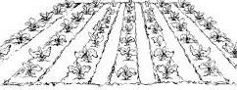

Advantages of row planting.
- It makes weeding easy
- It controls easy spread of pests and diseases.
- It avoids wastage of seeds
- It makes harvesting easy
- It is easy to spray the crops
- It allows proper spacing of crops
- It enables the use of machines.
Disadvantages ofrowplanting.
- it needs a lot of labour
- it wastes land
- It requires a lot of skills
- It is time consuming
- It requires large piece of land
- It is tiresome.
Examples of plants planted by row planting
_ maize plants _beans plant
_ coffee plants _ passion fruit plant
_ cassava plants _ Ground nut
_ cabbage plants _ potato plants
MINI ACTIVITY
1. Write down any two examples of plants by row planting.
i) ___________________________ ii) _________________________________
2. State any two advantages of row planting.
i) ________________________________________________________________
ii) ________________________________________________________________

3. Give the meaning of row planting.
__________________________________________________________________
4. Mention any two disadvantages of row planting.
i) ________________________________________________________________
ii) _______________________________________________________________
BROADCASTING METHOD
This is the way of planting seeds by randomly scattering them in garden using hands.
This method is good for very small seeds,
EXAMPLES OF SEEDS PLANTED USING BROADCASTING
_ Millet, sorghum, semis, Rice, Sunflower, barley, peas
ADVANTAGES OF BROAD CASTING
- It saves time
- It is easy and quick
- It does not need a lot of labour
- It does not waste nutrients in soil
DISADVANTAGES OF BROAD CASTING METHODS
_ It makes weeding difficult.
_ It makes harvesting difficult
_ pest and diseases can easily spread.
_ It wastes seeds.
_ It causes compotion for nutrients and sun light.
_ Many seedlings may grow in the same area.
_ It burdens the farmer to him.
MINI ACTIVITY
1. What is the way of planting seeds by randomly scattering them in a garden using hands.
___________________________________________________________________________
2. How is broadcasting method different from row planting?
__________________________________________________________________________
3. Which season do farmers
i) Plant their crops in the garden
_________________________________________________________________________
ii) Harvest their crops.
_________________________________________________________________________
4. Give any two advantages of broadcasting method to crop farmers
i) _________________________________________________________________________
ii) ________________________________________________________________________
5. State any three crops planted by broad casting sees in soil
i) _______________________________________________________________________
ii) _______________________________________________________________________
iii) ______________________________________________________________________
MEGA ACTIVITY
1. Give any three reasons why farmers practices seeds selection.
i) _________________________________________________________________________
ii) _________________________________________________________________________
iii) _________________________________________________________________________
2. What is seed viability.
___________________________________________________________________________
3. State any two factors to consider when selecting planting materials.
i) ________________________________________________________________________
ii) ________________________________________________________________________
iii) _______________________________________________________________________
4. Why do farmers plant crops in wet season?
_________________________________________________________________________
5. Name this method of planting
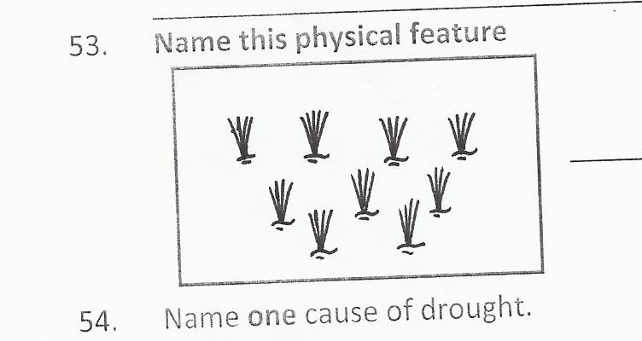

__________________________________________________

6. Why do farmers harvest crops in dry season.
__________________________________________________________________________
7. Mention any two plants planted by rows.
i)______________________________ii)________________________________________
8. State any two reasons why weeding is difficult in broadcasting method.
i) _________________________________________________________________________
ii) ________________________________________________________________________
9. Give any two advantages of planting crops in the wet season
i) ________________________________________________________________________
ii) ________________________________________________________________________
10. Identify the best season for planting crops in our environment.
i) _______________________________________________________________________

11. Why are farmers advised to water their seedlings?
_________________________________________________________________________
12. How useful are bees to plants?
__________________________________________________________________________
THEME: SCINCE IN HUMAN ACTIVITIES
TOPIC: CROP GROWING
LERANING OUTCOME: The leaner will be able to describe crop growing practices
Back ground knowledge: Crop growing practices.
Relevancy and functionality: The learner be able to put into practice the knowledge into daily life situations and care for plants in the garden.
Competences.
_ Defines weeding
_ Gives examples of weeds.
_ States the effects of weed to crops.
_ Gives ways of controlling weeds.
_ Gives advantages of early weeding.
_ Defines manuring and fertilizer application.
_ Identifies sources of manure.
Gives types of mulching
_ Defines mulching
_ Identifies advantages of mulching.
_ Defines pruning.
_ Gives advantages of pruning.
_ Defines thinning.
_ States advantages of thinning.
_ Defines watering -Gives advantages of watering.
_ Defines watering.
_ Defines crop rotation.
_ Identifies factors that are considered when rotating.
_ Defines harvesting and storing.
CONTENT.
Weeding phase 1
Definition.
Weeding is the removal of unwanted plants from the garden.
Weeds
Are un wanted plants in the garden.
They grow among crop and cause harm to crops.
EXAMPLE OF WEEDS
- Spear grass wandering jew _couch grass
- Elephant grass _ Guinea grass.
- Black jack _ Thorn apple.
- Star grass _ Wild finger millet
Dangers of weeds in the garden /effects of weeds
_ Weeds hide parts.
_ They reduce the space for crops to grow
_They encourage easy spread of pests.
_ They make harvesting difficult.
_ Weeds are complete with crops for sunlight.
_ Some weeds are poisonous to animals eg tick berry bush.
_ Weeds lead to poor growth of crops.
_Weeds make pruning, spraying of pesticides difficult.
_ Farmers spend a lot of money to control weeds.
MINI ACTIVITY.
1. What is meant by the term weeding?
__________________________________________________________________________

2. Identify any four examples of weeds.
i) _____________________________ ii) ________________________________________
iii) _____________________________ iv) ______________________________________
3. How are weeds dangerous to plants in the garden?
___________________________________________________________________________
4. Name one example of grass used in construction of houses.
___________________________________________________________________________
5. How do animals benefit from weeds?
___________________________________________________________________________
Ways / methods of controling weeds.
- Uprooting weeds. slashing
- Digging with a hoe. Rearing animals to feed on the weeds biological
- Burning the weeds Through crop rotation
- Through crop rotation Mulching
- Spraying with herbicides
Garden tool for weeding
Hand fork Hoe Slasher
ADVANTAGES OF WEEDING AGERDEN
- It reduces the competition for light and nutrients between crops and weeds.
- It makes harvesting easy.
- It controls the easy spread of diseases.
- It prevents the easy spread of crop pests.
- Weeding gives good space for pruning and spraying.
- Weeding reduces overcrowding of the garden with plants.
- Weeding reduces hiding places for pests.
ADVANTAGES OF WEEDS.
Weeds can be used as animal feeds eg elephant grass.
_Some weeds are a source of herbal medicine.
_ Weeds rot form manure.
_Some weeds are used as mulches.
_ Some weeds are used to thatch houses.
_ Some weeds are a source of food for pole.
_ Legume weeds improve on the soil fertility by adding nitrogen.
_ Weeds control soil erosion by providing good soil cover.
MEGA ACTIVITY.
1. What is meant by the term weeds?
___________________________________________________________________________

2. Give any one-way weeds are important to cattle keepers.
___________________________________________________________________________
3. Give any one garden tool used for weeding.
___________________________________________________________________________
4. How are weeds important to people?
__________________________________________________________________________
5. How are weeds useful to crop farmers?
__________________________________________________________________________
6. Draw this example of weed in the space provided below black jack

7. In which way do weeds reduce crop yields?
___________________________________________________________________________
8a) State any three importance of weeding crops in the garden.
i) _________________________________________________________________________
ii) ________________________________________________________________________
iii) _________________________________________________________________________
b) How do weeds hider proper growth of crops?
_________________________________________________________________________
9a) Mention any two advantages of weeds to
i) people.__________________________________________________________________
ii) animals.________________________________________________________________
10a) Give any two ways of controlling weeds in the garden.
i) _________________________________________________________________________
ii) ________________________________________________________________________
b) Name these garden tools used for weedind

Phase 2
Manuring and fertilizer application
This is the application of fertilizer/ manure in the soil to make it more fertile.
Manuring is the act of adding manure to soil
Manure are natural fertilizers.
Manure helps to improve soil fertility.
SOURCES OF MANURE.
- Animal during and urine.
- Plant remains
- Green plants
Types of manure (natural fertilizers)
1. Compost manure;
It is got from plant materials and animals wastes.
2. Green manure:
It is made from green plants when ploughed into soil.
3. Farmyard manure (FYM)
It is made from animals dung and urine.
4. Organic mulches
It is through mulching using dry plant materials.
MULCHING.
This is the covering of the top soil with dry plant materials.
The materials used to cover the top soil are called mulches.
Examples of mulches
- Dry grass like spear grass, elephant grass etc
- Dry banana leaves Maize straws
- Sorghum Dry leaves
- Wood shaving
- Chopped stems of bananas
EXAMPLES OF PLANTS COMMONLY MULCHED
- Banana plants Tomatoes Cabbage Coffee

IIUSTRATIONS SHOWING MULCHING.

MINI ACTIVITY
1. Mention any two sources of manure.
i) ________________________________________________________________________
ii) ________________________________________________________________________
2. Give any four examples of mulches.
i) ______________________________ ii)_______________________________________
iii) _______________________________iv)______________________________________
3. Identify any three types of natural fertilizers
i) ________________________________ ii) _______________________________________
ii_________________________________
4. Name three examples of plants commonly mulched
i) __________________ii)____________________iii)______________________________
ADVANTAGES OF MULCHING.
- Mulching controls soil erosion by reducing the speed of flowing water.
- Mulching maintains soi fertility by reducing soil erosion
- It improves on soil fertility when mulches rot and farm manure.
- Mulching keeps water in the soil/ it conserve soil moisture.
- Mulching increases on the crop yields by improving on soil fertility.
- Mulching reduces the growth of weeds.
- It increases water infiltration in the soil.
- Mulching maintains soil moisture by reducing water evaporation from the soil
DISADVANTAGES OF MULCHING.
- Mulches keep/ hide pests.
- Some mulches can grow into weeds.
- Mulching is expensive.
- Mulches may act as breeding places for crop pests.
- Mulching is tiresome.
- Mulches can easily catch fire and destroy crops.
- A thick layer of mulches can prevent rain water from the soil
MINI ACTIVITY
1. How does mulching control soil erosion.
__________________________________________________________________________
2. Give any two dangers of mulches in the garden.
i) _________________________________________________________________________
ii) _________________________________________________________________________
3. How does mulching control the growth of weeds in the garden.
___________________________________________________________________________
4.State any two reasons for mulching the garden
i) __________________________________________________________________________
ii) _________________________________________________________________________
5. Name any two examples of mulches
i) _________________________________ ii)_____________________________________
MEGA ACTIVITY
1. State the meaning mulching
___________________________________________________________________________
2. How is manuring important to a crop farmer?
___________________________________________________________________________
3. How does mulching improve on soil fertility?
__________________________________________________________________________
4. How does mulching control soil erosion?
__________________________________________________________________________
5. How does mulching maintain soil moisture?
__________________________________________________________________________
6. Give any one examples of mulches?
___________________________________________________________________________
7a). write any one method of applying fertilizers in the soil
____________________________________________________________________________

b) Mention any two materials used to make natural fertilizers?
i) ______________________________ii)______________________________________
c) What is the difference between organic mulches and farm yard manure
_________________________________________________________________________
8a) John is farmer, he grows bananas and cabbages how can he control soil erosion and improve soil fertility.
_____________________________________________________________________________
b) Why to farmers mulch their gardens?
___________________________________________________________________________

9a) Identify any two materials farmers use to mulch their gardens.
i) _________________________________ii)______________________________________
b) Mention any two disadvantages of mulching.
i) ________________________________________________________________________
ii) ________________________________________________________________________
PHASE 3
This is the removal of excess branches or leaves from a plant
GARDEN TOOLS USED FOR PRUNING.
- Secateur Pruning /pruner
- Panga shears
Examples of plants usually pruned.
- Banana coffee cocoa Lemons oranges Tomato
ADVANTAGES OF PRUNING.
- It controls pests by removing their hiding places.
- It eases harvesting.
- It promotes proper growth of the plant which prevents breaking.
- Pruned materials can be used for mulching.
- It reduces the easy spread of crop diseases.
- It reduces competition for sunlight and yield more
MINI ACTIVITY.
1. What term is given to the removal of excess branches or leaves from a plant?
__________________________________________________________________________
2. Mention any two tools used for pruning
i) __________________________________ ii) __________________________________

3. Identify any three reasons why farmers should prune their crops
i) _________________________________________________________________________
ii) ________________________________________________________________________
iii) _______________________________________________________________________

